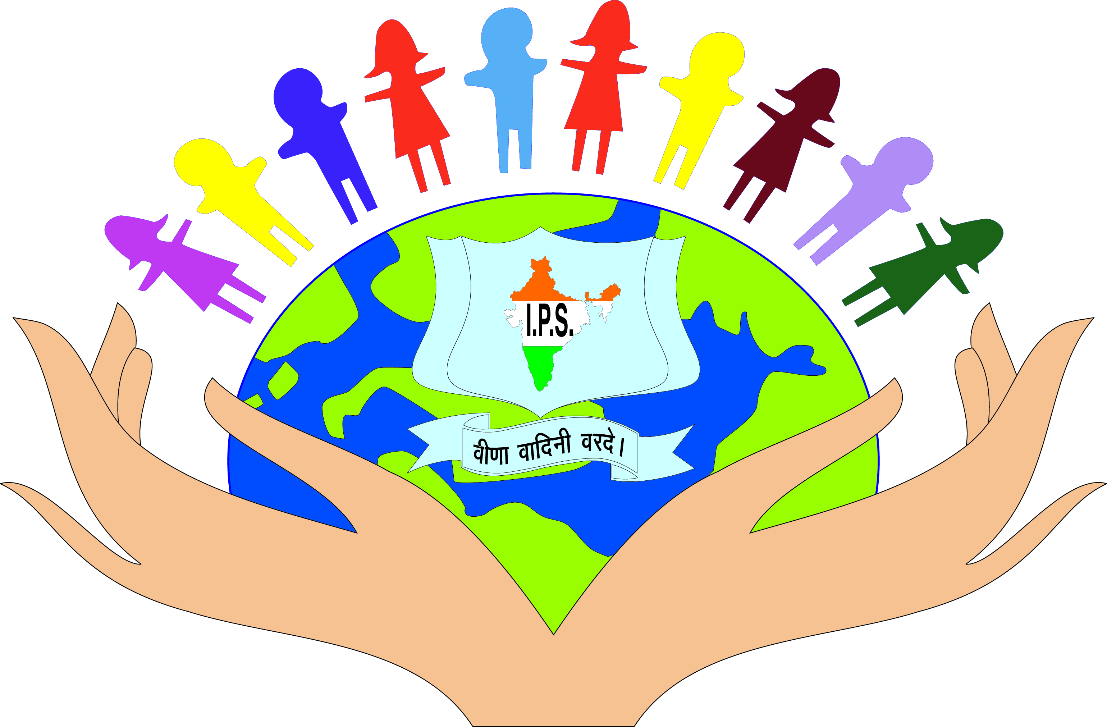
IDEAL PUBLIC SCHOOL
Plot No. 7, I Block, Shiv Durga Vihar Lakkarpur, Faridabad
Activities of the year 2026-2027
Date | Activities
April 2026
01/04/2026 | Welcome Programme
02/04/2026 | English Calligraphy
08/04/2026 | Banner Making VI- XII
13/04/2026 | Baisakhi Celebration
22/04/2026 | Juniors Declamation / Earth day
17/04/2026 | Drawing - 1 to 5
29/04/2026 | Parents Orientation / Welcome Meet (Nur+KG)
May 2026
01/05/2026 | Appreciation + Labour Day + Helping Staff Day
08/05/2026 | Mother's Day (Nur + KG)
15/05/2026 | Baby's Day Out ( Nur + KG)
15/05/2026 | Investiture Ceremony
23/05/2026 | Summer Party ( Nur-8th)
26/05/2026 | Summer Party (9th - 12th)
31/05/2026 | Teacher's Party
July 2026
08/07/2026 | English Rhymes (Nur-IInd)
15/07/2026 | Story Telling 3rd to 5th
29/07/2026 | Talent Hunt (New Students)
17/07/2026 | Ice-Cream Day
22/07/2026 | Rainy Day / Mango Day
31/07/2026 | Plantation Rally
August 2026
06/08/2026 | Hindi Rhymes
25/08/2026 | Mehandi competition/ Solo Dance
08/08/2026 | Solo Singing
26/08/2026 | Onam Celebration
14/08/2026 | Independence Day ( Nur + 12th)
14/08/2026 | Independence Day
27/08/2026 | Rakhi Celebration (Nur + K.G)
September 2026
01/09/2026 | Rally on Cleanliness (9th to 12th)
03/09/2026 | Janmashtami Celebration
05/09/2026 | Folk Dance (Senior Teacher’s Day)
05/09/2026 | Teacher’s Day Outing
09/09/2026 | Rhyme – 3rd to5th
14/09/2026 | Ganesh Sthapna/ Hindi Diwas/ Paper Folding
26/09/2026 | Food without Fire
 | October 2026
02/10/2026 | Gandhi Jayanti
17/10/2026-20/10/2026 | Autumn Break (01st – 05th)
17/10/2026 | Dusshera
 | November 2026
01/11/2026 | Haryana Diwas
14/11/2026 | Children’s Day / Carnival (students + Teachers)
07/11/2026 | Rangoli competition
08/11/2026-11/11/2026 | Diwali Break
19/11/2026 | Quiz Competition Junior
12/11/2026 | Declamation Junior
24/11/2026 | Guru Parv
 | December 2026
 | Annual Function
08/12/2026 | Sports Week (6th – 10th)
24/12/2026 | Christmas Celebration
30/12/2026 | Winter Party
31/12/2026 | Teachers Winter Break
January 2027
13/01/2027 | Lohri Celebration
14/01/2027 | Makar Sankranti
20/01/2027 | School Inception Day
23/01/2027 | Subhash Chandra Jayanti
25/01/2027 | Republic Day (Nur to II)
February 2027
12/02/2027 | Punyatithi of Maa Badami Devi
15/02/2027 | Shivratri
 | Farewell XIIth
 | Graduation ceremony felicitation
March 2027
22/03/2027 | Holi
31/03/2027 | P.T.M
ENRICHMENT | OTHER's
Hindi | Calligraphy Competition
English | Story Telling
Maths | Tiffin Display
Sciecne | Dusshera Celebration + Dandiya Ras
Social Science | Bal Bhawan Activities
I.T | Group Song Junior + senior
 | Group Dance Junior + Senior
 | Solo Song + solo Dance
 | Rangoli + Drawing + Face Painting + Declamation + Fancy Dress + Best Dramebaz

# All Saturday’s will be off for students NUR to VIII only.
# 9 to 12 working with teachers.
List of Holidays |  |  |  | Vacation Schedule
 |  |  |  | 18/05/2026-29/06/2026 | Summer Break (Nur to VIII)
14/04/2026 | Tuesday | Baisakhi/ Ambedkar Jayanti |  | 18/05/2026-29/06/2026 | Summer Break (Nur to VIII)
31/07/2026 | Thursday | Shaheed Udham Singh |  | 24/05/2026-29/06/2026 | Summer Break (IX to XII)
15/08/2026 | Saturday | Independence Day |  | 24/05/2026-29/06/2026 | Summer Break (IX to XII)
28/08/2026 | Wednesday | Raksha Bandhan |  | School will Reopen on 30/06/2026 (Monday)
 |  |  |  | 17/10/2026-20/10/2026 | Autumn Break
04/09/2026 | Friday | Janmasthmi |  | 17/10/2026-20/10/2026 | Autumn Break
 |  |  |  | 08/11/2026-11/11/2026 | Diwali Break
02/10/2026 | Friday | Gandhi Jayanti |  | 08/11/2026-11/11/2026 | Diwali Break
19/10/2026 | Monday | Ram Navami
20/10/2026 | Tuesday | Dussehra
26/10/2026 | Monday | Valmiki /Ajmidh Jayanti
08/11/2026 | Sunday | Diwali
24/11/2026 | Tuesady | Guru nanank Jayanti
25/12/2026 | Friday | Christmas
01/01/2027 | Friday | New Year
14/01/2027 | Thursday | Makar Sankranti
26/01/2027 | Tuesday | Republic Day
22/03/2027 | Monday | Holi

